Requirements Analysis
Data Flow Diagram & User Stories
Date: | 29/10/2025
Team ID: | NM2025TMID01821
Project Name: | Streamlining Ticket Assignment for Efficient Support Operations
Maximum Marks: | 4 Marks

Data Flow Diagram
A Data Flow Diagram (DFD) visually represents how data moves through the system. In this project, the DFD illustrates how support tickets are created, how they are automatically assigned to appropriate agents, how assignment decisions are made based on skills and workload, and how performance data is tracked and reported. It ensures clarity in how data flows between users, processes, and storage components.
Example:
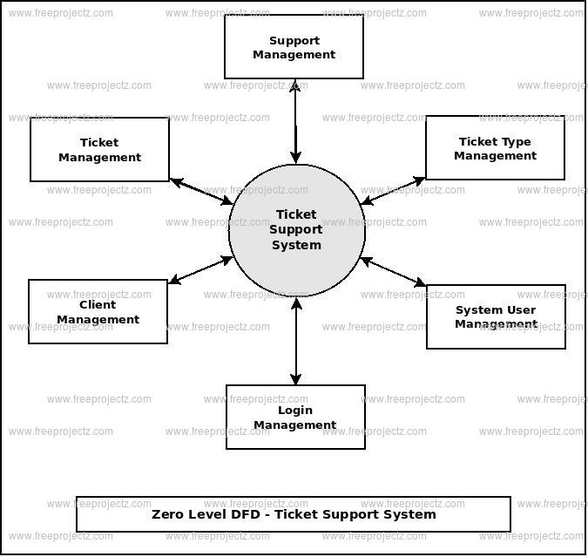

User Stories Table
User Type | Functional Requirement (Epic) | User Story Number | User Story / Task | Acceptance Criteria | Priority | Release
Agent | Skill Profile Management | USN-1 | As an agent, I want to maintain my skill profile so that I receive tickets matching my expertise. | Agent can update skills, proficiency levels are saved, profile reflects accurately in assignment logic. | High | Sprint-1
System | Auto-Assignment | USN-2 | As a system, I must automatically assign incoming tickets to qualified agents based on skills and workload. | Ticket is assigned within 10 seconds, agent has matching skills, assignment logged in audit trail. | High | Sprint-2
Customer | Assignment Transparency | USN-3 | As a customer, I want to know who is assigned to my ticket immediately after submission. | Customer receives email with agent name and contact details within 1 minute of ticket creation. | High | Sprint-5
Manager | Workload Visibility | USN-4 | As a manager, I want to see real-time workload distribution across my team. | Dashboard displays current ticket count per agent, updates in real-time, shows capacity status. | High | Sprint-4
Agent | Personal Queue | USN-5 | As an agent, I want to view all my assigned tickets in priority order. | Agent portal shows assigned tickets, sorted by priority, with quick action buttons available. | Medium | Sprint-5
System | Priority Routing | USN-6 | As a system, I must route high-priority tickets to senior agents immediately. | P1 tickets assigned to senior agents within 30 seconds, junior agents excluded from P1 pool. | High | Sprint-3
Admin | Skills Configuration | USN-7 | As an admin, I want to define skill categories and map them to ticket types. | Admin can create skill categories, map to ticket categories, changes reflect in assignment logic. | High | Sprint-1
System | Workload Balancing | USN-8 | As a system, I must prevent agent overload by checking capacity before assignment. | System checks current ticket count, assignment blocked if agent at max capacity (12 tickets). | High | Sprint-3
Manager | Escalation Alerts | USN-9 | As a manager, I want to be alerted when tickets remain unassigned beyond thresholds. | Alert email sent if ticket unassigned for 15 minutes, includes ticket details and suggested actions. | High | Sprint-4
Agent | Assignment Notification | USN-10 | As an agent, I want to receive instant notifications when tickets are assigned to me. | Email notification sent within 5 seconds, includes ticket summary, priority, and quick link. | High | Sprint-5
System | Availability Check | USN-11 | As a system, I must exclude unavailable agents from assignment pool. | System checks agent status (Active/Away/Busy), excludes non-active agents from assignment. | Medium | Sprint-3
Manager | Performance Reports | USN-12 | As a manager, I want to access reports showing assignment efficiency metrics. | Reports display assignment time, skills accuracy, workload balance, exportable as PDF/Excel. | Medium | Sprint-6
Admin | Audit Trail | USN-13 | As an admin, I want to view complete audit logs of all assignment decisions. | Audit log shows who, what, when, why for every assignment, searchable and filterable. | High | Sprint-6
Customer | Status Tracking | USN-14 | As a customer, I want to track the status of my ticket in real-time. | Customer portal displays current status, assigned agent, estimated response time, updated live. | Medium | Sprint-5
System | Escalation Processing | USN-15 | As a system, I must automatically escalate tickets that exceed assignment time thresholds. | Scheduled job runs every 5 minutes, identifies delayed tickets, triggers reassignment or alert. | High | Sprint-4
Agent | Reassignment Request | USN-16 | As an agent, I want to request reassignment if a ticket is outside my expertise. | Agent can click "Request Reassignment" button, manager receives alert, ticket re-queued. | Medium | Sprint-5
Manager | Manual Override | USN-17 | As a manager, I want the ability to manually assign or reassign tickets when needed. | Manager can select agent from dropdown, override automatic assignment, reason captured in log. | Medium | Sprint-4
System | Round-Robin Distribution | USN-18 | As a system, I must distribute tickets evenly among agents with equal qualifications. | When multiple agents qualify, system assigns to agent with lowest current workload. | High | Sprint-3
Admin | Rule Configuration | USN-19 | As an admin, I want to configure assignment rules and thresholds. | Admin interface allows setting max capacity, escalation times, priority rules, saved to system. | High | Sprint-1
Agent | Skills Certification | USN-20 | As an agent, I want to upload certifications to validate my skill profile. | Agent can attach certification documents, admin can verify and approve, status shown on profile. | Low | Sprint-6

